系統性文獻搜尋：紀錄表
請搭配SR檢索工具組: https://sunfloraf-sketch.github.io/sr-search-toolkit/pico-builder.html

研究問題
Question: | 妊娠糖尿病患者增加身體活動能有效控制血糖嗎？
Population | 妊娠糖尿病患者
Intervention | 身體活動
Comparison | 常規照護
Outcome | 血糖控制 (此例實務上不會訂定單一outcome，也不會納入檢索)
問題類型： | Therapy/Prevention ☐Diagnosis ☐Etiology ☐Other:
收錄研究設計： | RCTs ☐ Cohort Studies ☐Systematic Reviews ☐Other:
我的研究設計： | SR/MA ☐Scoping Review ☐Umbrella Review ☐Other
備註：

1b. 已知研究: 若有，填寫文章篇名或doi
- Effects of Axivity 3.0-based management model on pregnant women with gestational diabetes mellitus (10.3389/fendo.2026.1722822)
- Acute responses to structured aerobic and resistance exercise in women with gestational diabetes mellitus (10.1111/sms.13076)

1c. 資料庫與搜尋結果
資料庫  Database | 儲存  檢索歷史 | 搜尋日期  Date searched | 筆數Citations
資料庫  Database | 儲存  檢索歷史 | 搜尋日期  Date searched | 搜尋結果  Records identified from |  | 篇名摘要待篩選  Records screened |  | 全文待獲取  Reports sought for retrieval |  |  | 全文待篩選  Reports assessed for eligibility |  | 納入分析 Included
- Embase |  |  |  |  | included: |  | included: |  |  | included: |  | Studies included in review:  Reports of included studies:
- MEDLINE (Ovid)
或PubMed二擇一
- Cochrane CENTRAL
- CINAHL (EBSCOhost)
- Scopus或WOS
- ICTRP
other sources | - | -
文獻篩選流程PRISMA flow diagram:  篩選流程管理與去重複書目，可利用相關工具，例如EndNote、Rayyan等進行管理。 |  |  |  | included:
 |  |  |  | de-duplicates: |  | excluded: |  |  | excluded: |  | excluded:  說明排除理由

2a. 檢索詞: 自我檢核
 |  | 自由詞彙：英文同義字 | 控制詞彙
蒐集  管道 |  | ☐控制詞彙表之同義詞清單  ☐控制詞彙表之狹義控制詞彙  ☐Cochrane SR: Search Strategies Appendices; Supplementary; Methods  ☐瀏覽相關文章  ☐生成式AI | ☐詞表查詢＞決定控制詞彙位階(廣/狹)  ☐高相關文章的控制詞彙給了甚麼  index term, index miner, subject filter  ☐Cochrane SR: Search Strategies  Appendices; Supplementary; Methods  ☐ 交叉檢查不同控制詞彙表的對應：若Embase有某個控制詞彙，應該推想另一個資料庫(MEDLINE等)也可能有對應的控制詞彙，反之亦然
重要  檢核 |  | ☐單字切截處理  跨庫通用性，建議使用字尾切截*，並使至少要包含名詞單複數，  必要時再擴至形容詞與動詞  字頭起始太短時，避免使用切截  例：hear*誤找heart。解法直接列出可能字尾變化hear、hearing  ☐詞彙去冗: 輸入一個單字(詞)即能找出含括者，不需冗贅列出  例: 使用exercise即能找到exercise therapy、physical exercise…  例: 使用"quality of life"能找到"health-related quality of life"  無法找到"life quality", "quality-adjusted of life"  ☐指定單字間的距離: 一個詞彙由兩個單字(含以上)組成時  例gestational diabetes，必須指定其為下列三種關係之一  文章數由少到多如下，建議採用鄰近字或片語(超重要!)  片語: "gestational diabetes" (採"雙直引號" 優於 “上下引號” 設定說明)  鄰近字: (gestational 鄰n單字內 diabetes)  有多個同義詞時，可分群簡化表達參考範例P或下圖  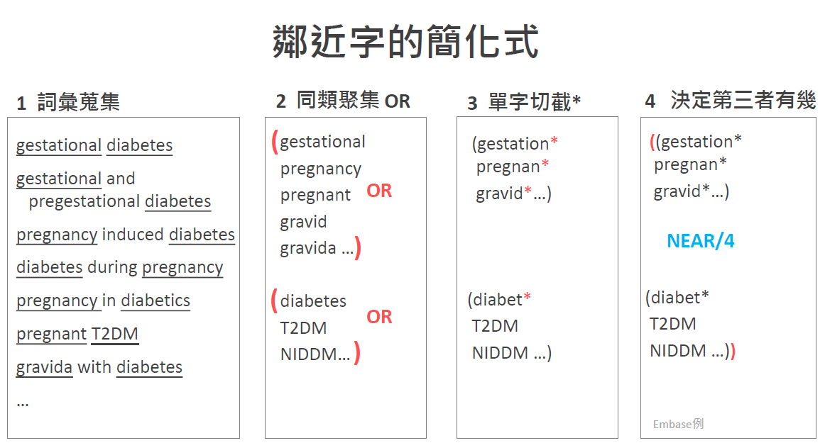  交集: (gestational AND diabetes)  ☐連字符號: 例anti-cancer = "anti cancer" ≠ anticancer  ☐所有格: "Parkinson* Disease*"  在Embase無法找出 "Parkinson's Disease*" ('s被視為一個單字)  三解法擇一: 只輸入Parkinson* (當不會找到太多非疾病時)  (Parkinson* NEXT/2 Disease*)  "Parkinson* Disease*" OR "Parkinson s Disease*" (勿用單引號's)  ☐舒適閱讀很重要，檢索詞大小寫法請一致 | ☐控制詞彙無切截用法，例 Exercise*  ☐控制詞彙的廣狹義(位階)  無互屬：適用都列出  Exercise  Exercise Therapy  有互屬：列出最適用位階詞 (皆列出亦可)  Exercise  Running  Exercise可包含Running等所有狹義詞的語法:  Embase: "Exercise"/exp  MEDLINE (Ovid): exp "Exercise"/  語法請設定自動納入所有狹義詞  筆記時請利用縮格呈現廣狹義，有利釐清關係  可標灰表示不需檢索  ☐偶有特殊考量，不欲加入所有狹義詞者，請加註「(不含所有狹義詞)」，並於「4搜尋策略」採用對應檢索語法（參考附錄1）  physical activity, capacity and performance (不含所有狹義)  physical activity  Embase語法為" physical activity, capacity and performance "/de OR "physical activity"/exp

2b. 檢索詞 每換行代表OR (不須標示) 在此請專注於詞彙整理
主題概念  🔪切出來 | 自由詞彙 Free Text |  |  | 控制詞彙 Controlled Vocabulary
主題概念  🔪切出來 | 中文同義字 | Before ^{English Synonyms} | After ^{English Synonyms} | Emtree | MeSH | CINAHL Headings
P | ((妊娠  孕期  懷孕)  AND  糖尿病) | gestational diabetes  gestational T2DM  gestational NIDDM  pregnant diabetes  pregnancy-induced diabetes  diabetes mellitus gravidarum  GDM  … | GDM  ((gestation*  pregnan*  gravid*)  鄰3單字內  (diabet*  T2DM  NIDDM)) | maternal diabetes mellitus  gestational diabetes  pregnancy in diabetics  灰字狹義詞自動納入檢索 | Diabetes, Gestational  Pregnancy in Diabetics
I | 身體活動  體能活動  運動  訓練  走路 |  | GDM  ((gestation*  pregnan*  gravid*)  鄰3單字內  (diabet*  T2DM  NIDDM)) | maternal diabetes mellitus  gestational diabetes  pregnancy in diabetics  灰字狹義詞自動納入檢索 | Diabetes, Gestational  Pregnancy in Diabetics
C | (若常規不需檢索) | - | - | -
O | 血糖  糖化血色素

搜尋策略（投稿時附上此項為Appendix）
資料庫  Database | # | 搜尋語法  Search syntax | 結果筆數Citations found
Embase.com (Elsevier) | 1 | (GDM OR ((gestation* OR pregnan* OR gravid*) NEAR/4 (diabet* OR T2DM OR NIDDM))):ti,ab,kw | [Ctrl+H]  尋找目標^p  取代為 OR  (留意OR前後空格須包含)
Embase.com (Elsevier) | 2 | "maternal diabetes mellitus"/exp | [Ctrl+H]  尋找目標^p  取代為"/exp OR "
Embase.com (Elsevier) | 3 | (GDM OR ((gestation* OR pregnan* OR gravid*) NEAR/4 (diabet* OR T2DM OR NIDDM))):ti,ab,kw
Embase.com (Elsevier) | 4 | "maternal diabetes mellitus"/exp
Embase.com (Elsevier) | 5 | O自由詞彙
Embase.com (Elsevier) | 6 | O控制詞彙Emtree
Embase.com (Elsevier) | 7 | (#1 OR #2) AND (#3 OR #4) AND (#5 OR #6) AND [embase]/lim | All:
Embase.com (Elsevier) | 8 | #7 AND ("randomized controlled trial"/de or "controlled clinical trial"/de or "randomization"/de or "intermethod comparison"/de or "double blind procedure"/de or "human experiment"/de OR (random* or placebo or assigned or allocated or volunteer or volunteers or (open NEXT/1 label) or ((double or single or doubly or singly) NEXT/1 (blind or blinded or blindly)) or "parallel group?" or crossover or "cross over" or ((assign* or match or matched or allocation) NEAR/5 (alternate or group? or intervention? or patient? or subject? or participant?)) OR (controlled NEAR/7 (study or design or trial))):ti,ab OR (compare or compared or comparison or trial):ti OR ((evaluated or evaluate or evaluating or assessed or assess) and (compare or compared or comparing or comparison)):ab) NOT (((random* NEXT/1 sampl* NEAR/7 ("cross section*" or questionnaire? or survey* or database?)):ti,ab not ("comparative study"/de or "controlled study"/de or "randomi?ed controlled":ti,ab or "randomly assigned":ti,ab)) OR ("Cross-sectional study"/de not ("randomized controlled trial"/de or "controlled clinical study"/de or "controlled study"/de or randomi?ed controlled:ti,ab or "control group?":ti,ab)) OR ((((case NEXT/1 control*) and random*) not randomi?ed controlled):ti,ab) OR ("Systematic review" not (trial or study)):ti OR (nonrandom* not random*):ti,ab OR "Random field*":ti,ab OR ("random cluster" NEAR/3 sampl*):ti,ab OR ((review:ab and review/it) not trial:ti) OR ("we searched":ab and (review:ti or review/it)) OR "update review":ab OR (databases NEAR/4 searched):ab OR ((rat or rats or mouse or mice or swine or porcine or murine or sheep or lambs or pigs or piglets or rabbit or rabbits or cat or cats or dog or dogs or cattle or bovine or monkey or monkeys or trout or marmoset?):ti and "animal experiment"/de) OR ("animal experiment"/de not ("human experiment"/de or "human"/de)))  Filter Source: Box 3.e, Technical Supplement to Chapter 4: Searching for and Selecting Studies. Cochrane Handbook for Systematic Reviews of Interventions Version 6. (Syntax Translated from Ovid Embase to Elsevier Embase.com.) | RCT:
MEDLINE (Ovid) and Epub Ahead of Print, In-Process, In-Data-Review & Other Non-Indexed Citations  與PubMed  二擇一 | 1 | (GDM OR ((gestation* OR pregnan* OR gravid*) ADJ4 (diabet* OR T2DM OR NIDDM))).ti,ab,kf.
 | 2 | exp "Diabetes, Gestational"/ OR exp "Pregnancy in Diabetics"/ | [Ctrl+H]  尋找目標^p  取代為"/ OR exp "
 | 3 | (GDM OR ((gestation* OR pregnan* OR gravid*) ADJ4 (diabet* OR T2DM OR NIDDM))).ti,ab,kf.
 | 4 | exp "Diabetes, Gestational"/ OR exp "Pregnancy in Diabetics"/
 | 5 | O自由詞彙
 | 6 | O控制詞彙MeSH
 | 7 | (1 OR 2) AND (3 OR 4)  不加# | ALL:
 | 8 | 7 AND ((randomized controlled trial.pt. or controlled clinical trial.pt. or randomized.ab. or randomised.ab. or placebo.ab. or drug therapy.fs. or randomly.ab. or trial.ab. or groups.ab.) not (exp animals/ not humans.sh.)) | RCT:
Cochrane Library: Trials (CENTRAL)  專收RCT研究設計，但非RCT研究若基於RCT所延續發表等，亦有可能收錄其中。若您的研究僅收RCT，可以自行衡量是否要加入此資料庫檢索)  注意:自2023/6起不支援鄰近字與切截併用，需修改語法為NEXT  "pregnan* diabet*  (pregnan* NEXT diabetes)  "post operat*"  (post-operat*)  "post*-operat*" | 1 | (GDM OR ((gestation* OR pregnan* OR gravid*) NEAR/4 (diabet* OR T2DM OR NIDDM))):ti,ab,kw
 | 2 | [mh "Diabetes, Gestational"] OR [mh "Pregnancy in Diabetics"] | 複製MEDLINE後:  [Ctrl+H]  尋找目標/ OR exp  取代為] OR [mh
 | 3 | (GDM OR ((gestation* OR pregnan* OR gravid*) NEAR/4 (diabet* OR T2DM OR NIDDM))):ti,ab,kw
 | 4 | [mh "Diabetes, Gestational"] OR [mh "Pregnancy in Diabetics"]
 | 5 | O自由詞彙
 | 6 | O控制詞彙MeSH
 | 7 | (#1 OR #2) AND (#3 OR #4) AND (#5 OR #6) | All:
 | 8 | #7 (用選單Limits: in Trials, Cochrane Reviews, Cochrane Protocols) | RCT:
CINAHL (EBSCOhost)  欄位與語法一定要大寫字母  進階查詢:所有查詢建議均不勾選  Apply related words  Apply equivalent subjects | 1 | TI (GDM OR ((gestation* OR pregnan* OR gravid*) N3 (diabet* OR T2DM OR NIDDM))) OR AB (GDM OR ((gestation* OR pregnan* OR gravid*) N3 (diabet* OR T2DM OR NIDDM))) OR KW (GDM OR ((gestation* OR pregnan* OR gravid*) N3 (diabet* OR T2DM OR NIDDM)))
 | 2 | P控制詞彙CINAHL Subject Heading  MH "Diabetes Mellitus, Gestational+" OR MH "Pregnancy in Diabetes+"  逐一附加 或 整串附加 mh  MH ("Diabetes Mellitus, Gestational+" OR "Pregnancy in Diabetes+") | [Ctrl+H]  尋找目標^p  取代為+" OR MH
 | 3 | TI (GDM OR ((gestation* OR pregnan* OR gravid*) N3 (diabet* OR T2DM OR NIDDM))) OR AB (GDM OR ((gestation* OR pregnan* OR gravid*) N3 (diabet* OR T2DM OR NIDDM))) OR KW (GDM OR ((gestation* OR pregnan* OR gravid*) N3 (diabet* OR T2DM OR NIDDM)))
 | 4 | I控制詞彙CINAHL Subject Heading
 | 5 | O自由詞彙
 | 6 | O控制詞彙CINAHL Subject Heading
 | 7 | (S1 OR S2) AND (S3 OR S4) AND (S5 OR S6) | All:
 | 8 | S7 AND (MH ("randomized controlled trials" OR "double-blind studies" OR "single‐blind studies" OR "random assignment" OR "pretest‐posttest design" OR "cluster sample") OR TI (randomised OR randomized) OR AB (random*) OR TI (trial) OR (MH (sample size) AND AB (assigned OR allocated OR control)) OR MH (placebos) OR PT (randomized controlled trial) OR AB (control W5 group) OR MH ("crossover design" OR "comparative studies") OR AB (cluster W3 RCT)) NOT ((MH ("animals+" OR "animal studies") OR TI (animal model*)) NOT MH (human)) | RCT:
Scopus  在進階介面輸入  (無控制詞彙) | 1 | TITLE-ABS (GDM OR ((gestation* OR pregnan* OR gravid*) W/3 (diabet* OR T2DM OR NIDDM))) OR AUTHKEY (GDM OR ((gestation* OR pregnan* OR gravid*) W/3 (diabet* OR T2DM OR NIDDM)))
Scopus  在進階介面輸入  (無控制詞彙) | 2 | TITLE-ABS (GDM OR ((gestation* OR pregnan* OR gravid*) W/3 (diabet* OR T2DM OR NIDDM))) OR AUTHKEY (GDM OR ((gestation* OR pregnan* OR gravid*) W/3 (diabet* OR T2DM OR NIDDM)))
Scopus  在進階介面輸入  (無控制詞彙) | 3 | O自由詞彙
Scopus  在進階介面輸入  (無控制詞彙) | 4 | (INDEXTERMS ( "clinical trials" OR "clinical trials as a topic" OR "randomized controlled trial" OR "Randomized Controlled Trials as Topic" OR "controlled clinical trial" OR "Controlled Clinical Trials" OR "random allocation" OR "Double-Blind Method" OR "Single-Blind Method" OR "Cross-Over Studies" OR "Placebos" OR "multicenter study" OR "double blind procedure" OR "single blind procedure" OR "crossover procedure" OR "clinical trial" OR "controlled study" OR "randomization" OR "placebo" ) OR TITLE-ABS-KEY ( "clinical trials" OR "clinical trials as a topic" OR "randomized controlled trial" OR "Randomized Controlled Trials as Topic" OR "controlled clinical trial" OR "Controlled Clinical Trials as Topic" OR "random allocation" OR "randomly allocated" OR "allocated randomly" OR "Double-Blind Method" OR "Single-Blind Method" OR "Cross-Over Studies" OR "Placebos" OR "cross-over trial" OR "single blind" OR "double blind" OR "factorial design" OR "factorial trial" ) OR TITLE ( clinical trial OR trial OR rct* OR random* OR blind* ))  Filter Source: This filter is built by NUS Medical Library using MESH and EMTREE terms as Index terms and Keywords. Useful to search in Scopus for RCTs.
Scopus  在進階介面輸入  (無控制詞彙) | 5 | 須切換到：基本搜尋Basic Search > Search History:打勾三項組合  > 點擊Combine queries > AND  #1 AND #2 AND #3 AND #4 | RCT:
Web of Science:  Core Collection  在進階介面輸入  (無控制詞彙) | 1 | TI=(GDM OR ((gestation* OR pregnan* OR gravid*) NEAR/3 (diabet* OR T2DM OR NIDDM))) OR AB=(GDM OR ((gestation* OR pregnan* OR gravid*) NEAR/3 (diabet* OR T2DM OR NIDDM))) OR AK=(GDM OR ((gestation* OR pregnan* OR gravid*) NEAR/3 (diabet* OR T2DM OR NIDDM)))
Web of Science:  Core Collection  在進階介面輸入  (無控制詞彙) | 2 | TI=(GDM OR ((gestation* OR pregnan* OR gravid*) NEAR/3 (diabet* OR T2DM OR NIDDM))) OR AB=(GDM OR ((gestation* OR pregnan* OR gravid*) NEAR/3 (diabet* OR T2DM OR NIDDM))) OR AK=(GDM OR ((gestation* OR pregnan* OR gravid*) NEAR/3 (diabet* OR T2DM OR NIDDM)))
Web of Science:  Core Collection  在進階介面輸入  (無控制詞彙) | 3 | O自由詞彙
Web of Science:  Core Collection  在進階介面輸入  (無控制詞彙) | 4 | #1 AND #2 AND #3 | All:
Web of Science:  Core Collection  在進階介面輸入  (無控制詞彙) | 5 | #4 AND (TS= clinical trial* OR TS=research design OR TS=comparative stud* OR TS=evaluation stud* OR TS=controlled trial* OR TS=follow-up stud* OR TS=prospective stud* OR TS=random* OR TS=placebo* OR TS=(single blind*) OR TS=(double blind*)) | RCT:

檢索截圖／備忘
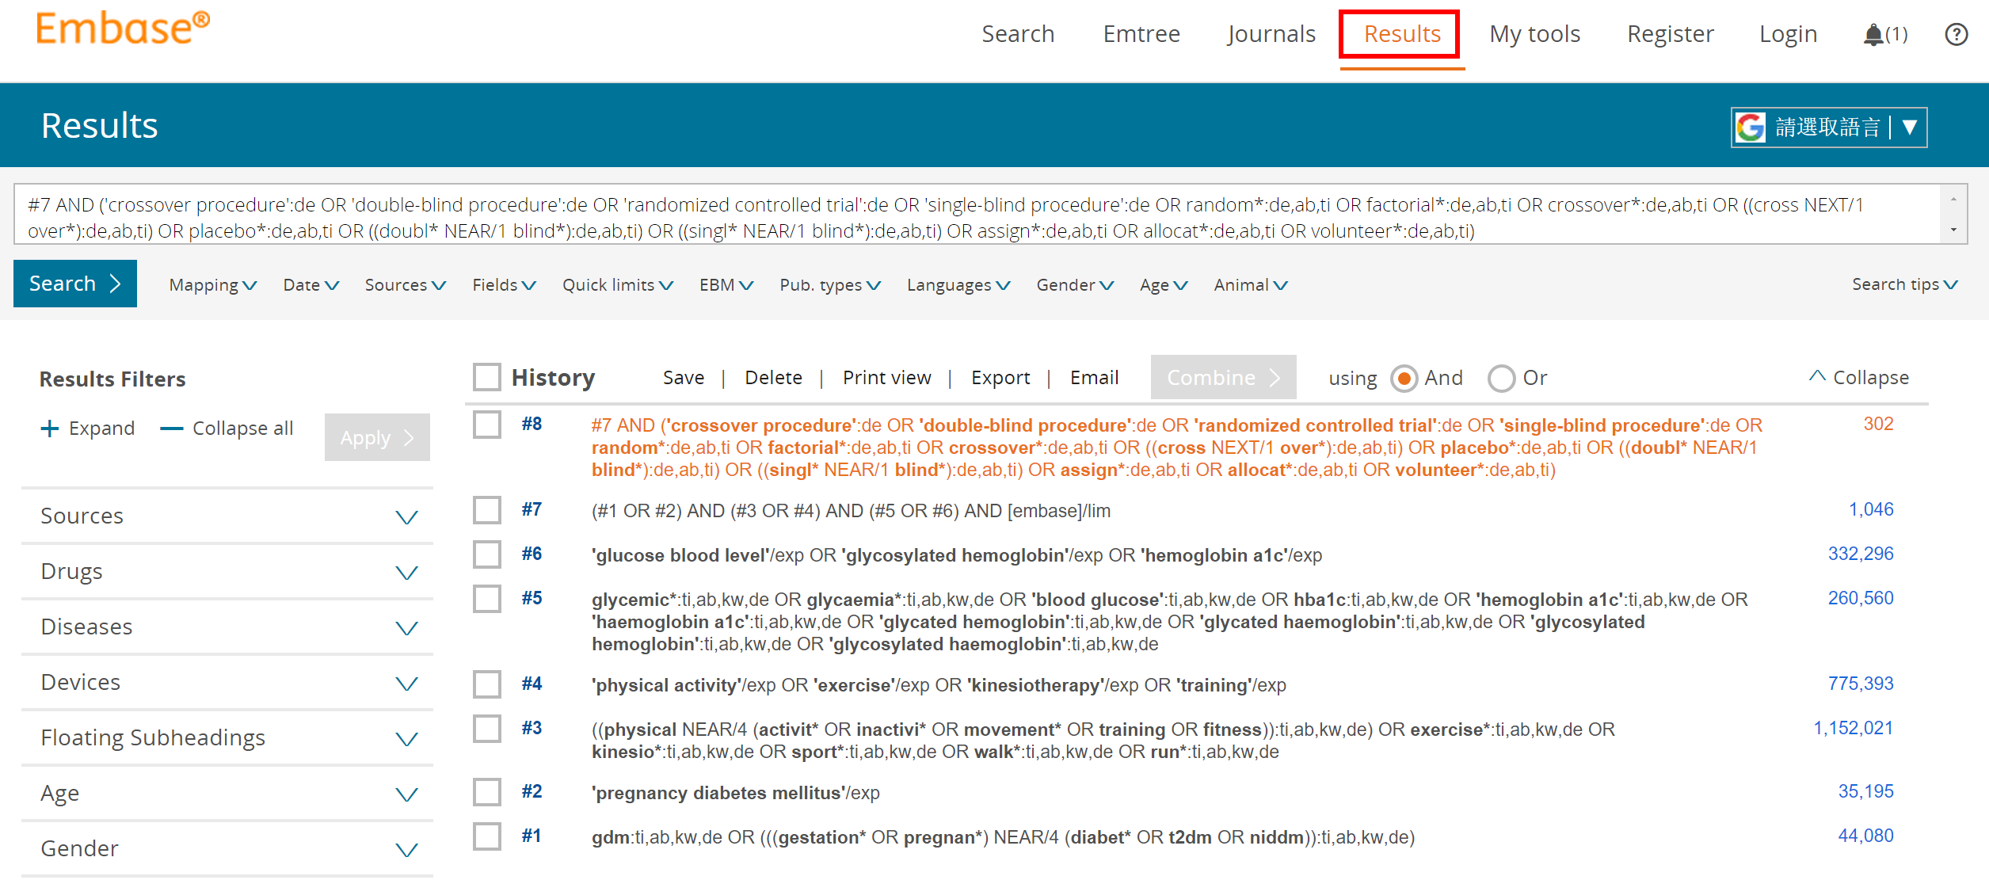
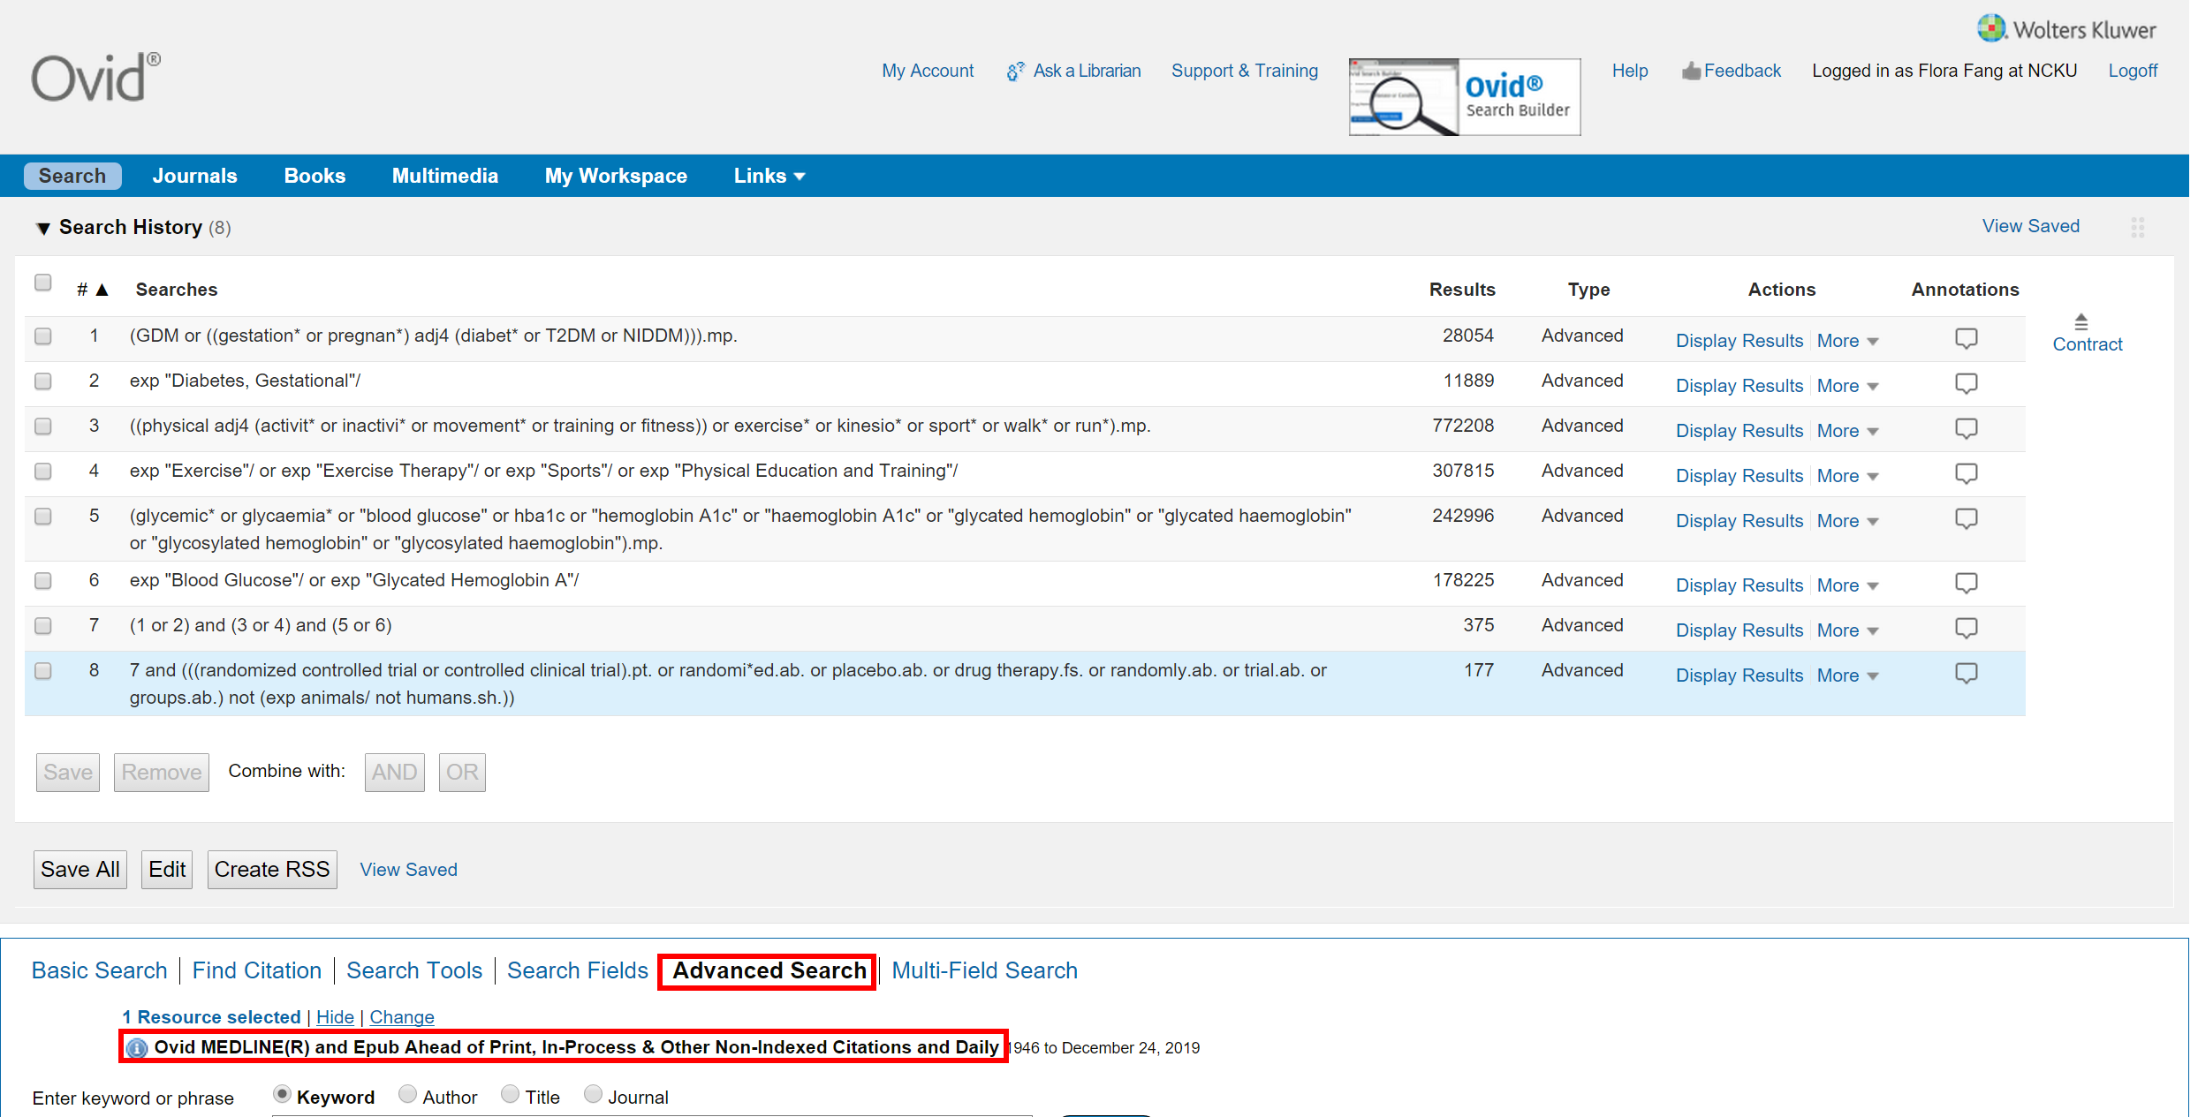

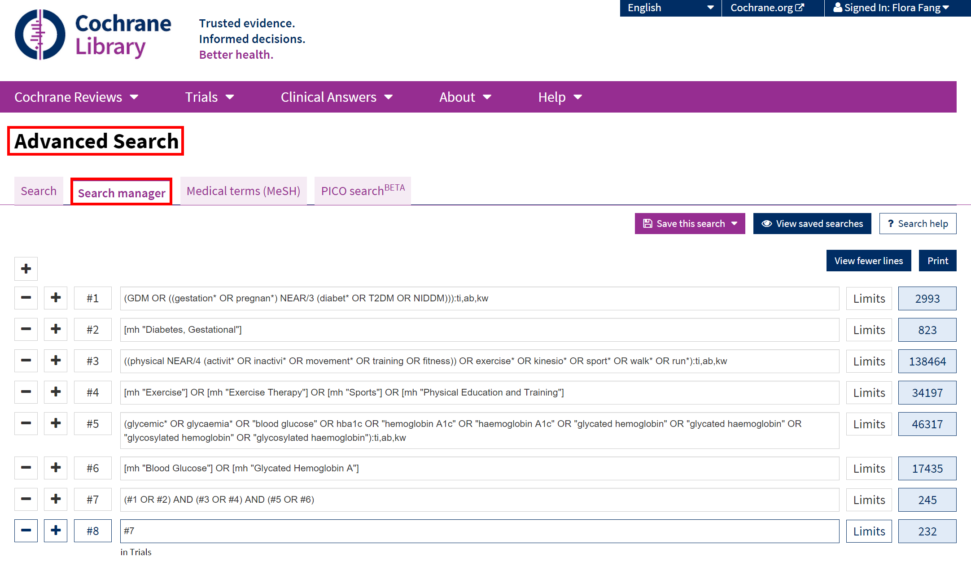

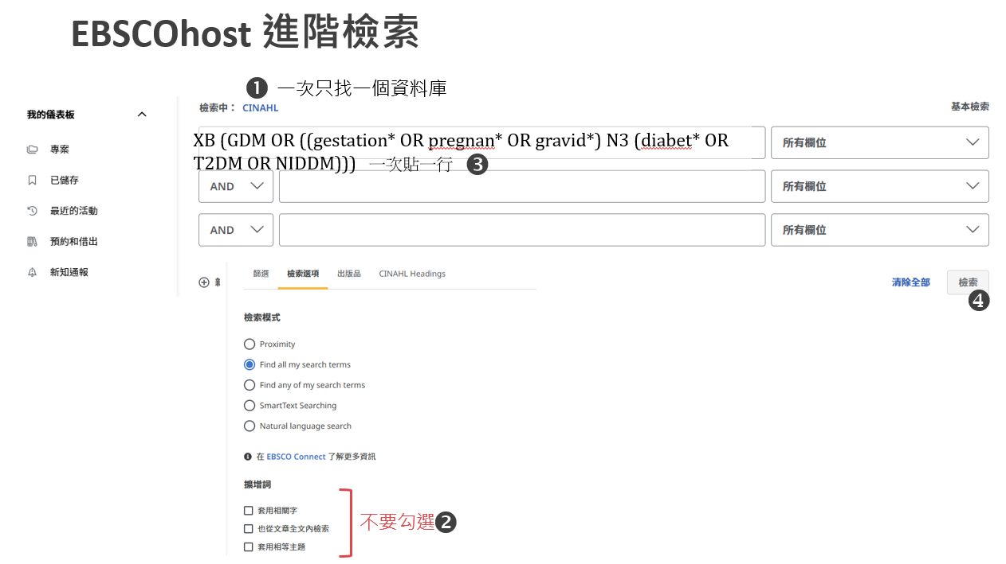
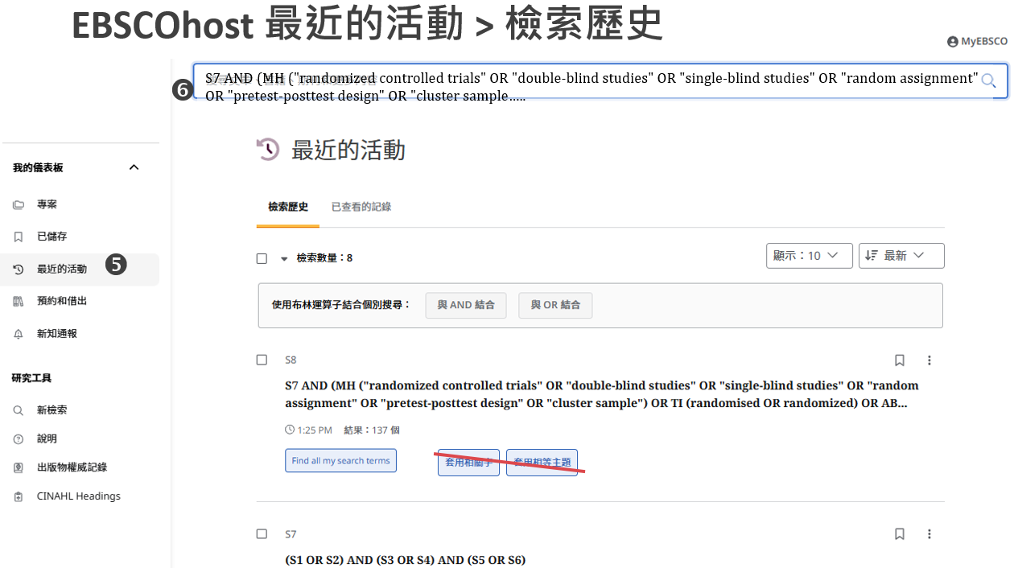

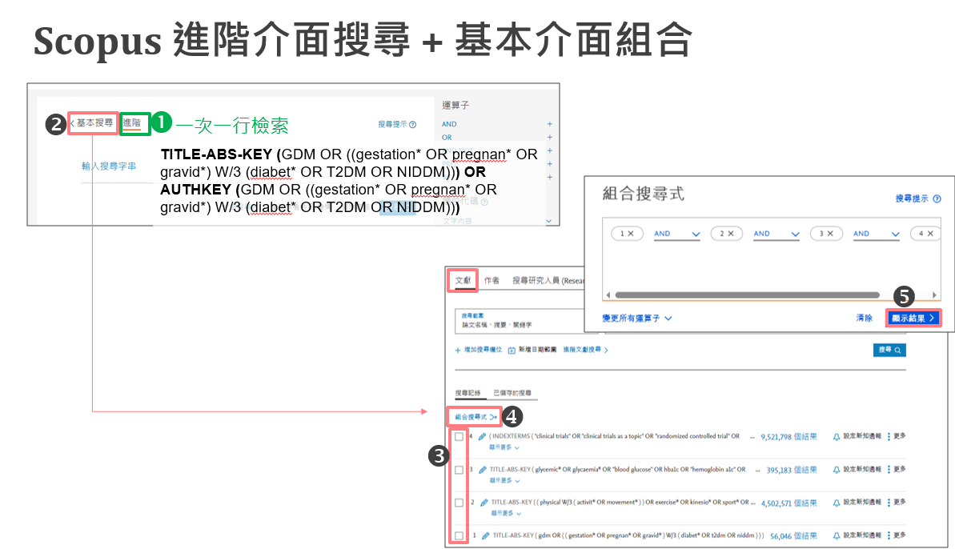

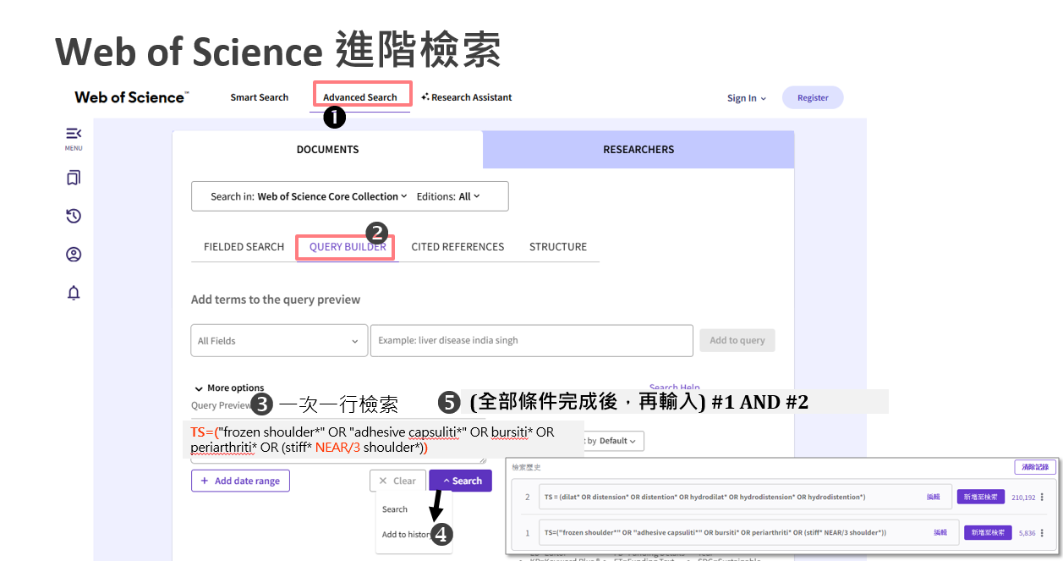

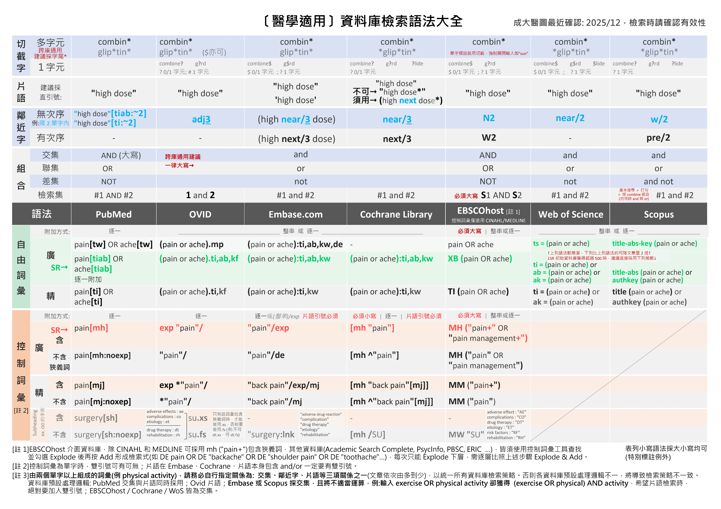
附錄1. 檢索語法大全

附錄2: 研究設計篩選語法：不同問題類型/研究設計、資料庫/平台，套用的Filters各異
更多篩選語法：
CADTH https://searchfilters.cda-amc.ca
ISSG https://sites.google.com/a/york.ac.uk/issg-search-filters-resource/
更多篩選語法：
CADTH https://searchfilters.cda-amc.ca
ISSG https://sites.google.com/a/york.ac.uk/issg-search-filters-resource/

附錄2-1: RCT (Cochrane Trials: CENTRAL即收錄RCT，無須套用Filter)
Embase.com (Elsevier) | Embase (Ovid) | Medline (Ovid) | Medline (PubMed) | CINAHL (EBSCOhost) | PsycInfo (Ovid) | Web of Science
("randomized controlled trial"/de or "controlled clinical study"/de or "randomization"/de or "intermethod comparison"/de or "double blind procedure"/de or "human experiment"/de OR (random* or placebo or "parallel group$" or crossover or "cross over" or assigned or allocated or volunteer or volunteers):ti,ab OR (open NEAR/1 label):ti,ab OR ((double or single or doubly or singly) NEAR/1 (blind or blinded or blindly)):ti,ab OR ((assign* or match or matched or allocation) NEAR/5 (alternate or group$ or intervention$ or patient$ or subject$ or participant$)):ti,ab OR (controlled NEAR/7 (study or design or trial)):ti,ab OR (compare or compared or comparison or trial):ti OR ((evaluated or evaluate or evaluating or assessed or assess) and (compare or compared or comparing or comparison)):ab) NOT (((random* NEAR/1 sampl* NEAR/7 ("cross section*" or questionnaire$ or survey* or database$)):ti,ab not ("comparative study"/de or "controlled study"/de or "randomi$ed controlled":ti,ab or "randomly assigned":ti,ab)) OR ("cross-sectional study"/de not ("randomized controlled trial"/de or "controlled clinical study"/de or "controlled study"/de or "randomi$ed controlled":ti,ab or "control group$":ti,ab)) OR ((((case NEAR/1 control*) and random*) not "randomi$ed controlled"):ti,ab) OR (("systematic review" not (trial or study)):ti) OR ((nonrandom* not random*):ti,ab) OR ("random field*":ti,ab) OR (("random cluster" NEAR/3 sampl*):ti,ab) OR ((review:ab and review/it) not trial:ti) OR ("we searched":ab and (review:ti or review/it)) OR ("update review":ab) OR ((databases NEAR/4 searched):ab) OR ((rat or rats or mouse or mice or swine or porcine or murine or sheep or lambs or pigs or piglets or rabbit or rabbits or cat or cats or dog or dogs or cattle or bovine or monkey or monkeys or trout or marmoset*):ti and "animal experiment"/de) OR ("animal experiment"/de not ("human experiment"/de or "human"/de)))  Filter Source: Box 3.e, Technical Supplement to Chapter 4: Searching for and Selecting Studies. Cochrane Handbook for Systematic Reviews of Interventions Version 6. (Syntax Translated from Ovid Embase to Elsevier Embase.com. 原出處Ovid Embase版，且為逐行檢索，此已由成大醫圖轉換並合併為一串)  (若此語法找出總文章量過多，可以洽詢改用其他RCTs語法) | ((Randomized controlled trial/) OR (Controlled clinical study/) OR (random$.ti,ab.) OR (randomization/) OR (intermethod comparison/) OR (placebo.ti,ab.) OR ((compare or compared or comparison).ti.) OR (((evaluated or evaluate or evaluating or assessed or assess) and (compare or compared or comparing or comparison)).ab.) OR ((open adj label).ti,ab.) OR (((double or single or doubly or singly) adj (blind or blinded or blindly)).ti,ab.) OR (double blind procedure/) OR (parallel group$1.ti,ab.) OR ((crossover or cross over).ti,ab.) OR (((assign$ or match or matched or allocation) adj5 (alternate or group$1 or intervention$1 or patient$1 or subject$1 or participant$1)).ti,ab.) OR ((assigned or allocated).ti,ab.) OR ((controlled adj7 (study or design or trial)).ti,ab.) OR ((volunteer or volunteers).ti,ab.) OR (human experiment/) OR (trial.ti.)) NOT ((random$ adj sampl$ adj7 ("cross section$" or questionnaire$1 or survey$ or database$1).ti,ab.) not (comparative study/ or controlled study/ or randomi?ed controlled.ti,ab. or randomly assigned.ti,ab.) OR (Cross-sectional study/ not (randomized controlled trial/ or controlled clinical study/ or controlled study/ or randomi?ed controlled.ti,ab. or control group$1.ti,ab.)) OR ((((case adj control$) and random$) not randomi?ed controlled).ti,ab.) OR ((Systematic review not (trial or study)).ti.) OR ((nonrandom$ not random$).ti,ab.) OR ("Random field$".ti,ab.) OR ((random cluster adj3 sampl$).ti,ab.) OR ((review.ab. and review.pt.) not trial.ti.) OR ("we searched".ab. and (review.ti. or review.pt.)) OR ("update review".ab.) OR ((databases adj4 searched).ab.) OR ((rat or rats or mouse or mice or swine or porcine or murine or sheep or lambs or pigs or piglets or rabbit or rabbits or cat or cats or dog or dogs or cattle or bovine or monkey or monkeys or trout or marmoset$1).ti. and animal experiment/) OR (Animal experiment/ not (human experiment/ or human/)))  Filter Source: Box 3.e, Technical Supplement to Chapter 4: Searching for and Selecting Studies. Cochrane Handbook for Systematic Reviews of Interventions Version 6. (原出處為逐行檢索，此已由成大醫圖合併為一串) | sensitivity-maximizing (優先採用):  (randomized controlled trial.pt. or controlled clinical trial.pt. or randomi*ed.ab. or placebo.ab. or drug therapy.fs. or randomly.ab. or trial.ab. or groups.ab. not (exp animals/ not humans.sh.))  Filter Source: Box 3.c, Technical Supplement to Chapter 4: Searching for and Selecting Studies. Cochrane Handbook for Systematic Reviews of Interventions Version 6. (Add: randomised.ab) | sensitivity-maximizing(優先採用):  (randomized controlled trial[pt] OR controlled clinical trial[pt] OR randomi*ed[tiab] OR placebo[tiab] OR drug therapy[sh] OR randomly[tiab] OR trial[tiab] OR groups[tiab] NOT (animals[mh] NOT humans[mh]))  Filter Source: Box 3.a, Technical Supplement to Chapter 4: Searching for and Selecting Studies. Cochrane Handbook for Systematic Reviews of Interventions Version 6. (Add: randomized[tiab]) | ((MH ("randomized controlled trials" OR "double-blind studies" OR "single‐blind studies" OR "random assignment" OR "pretest‐posttest design" OR "cluster sample") OR TI (randomised OR randomized) OR AB (random*) OR TI (trial) OR (MH (sample size) AND AB (assigned OR allocated OR control)) OR MH (placebos) OR PT (randomized controlled trial) OR AB (control W5 group) OR MH ("crossover design" OR "comparative studies") OR AB (cluster W3 RCT)) NOT ((MH ("animals+" OR "animal studies") OR TI (animal model*)) NOT MH (human)))  Filter Source: Box 3.f., Technical Supplement to Chapter 4: Searching for and Selecting Studies. Cochrane Handbook for Systematic Reviews of Interventions Version 6. | Watson et al:  ("Treatment Effectiveness Evaluation"/ OR exp "Treatment Outcomes"/ OR "Placebo"/ OR "Followup Studies"/ OR (placebo* OR random* OR "comparative stud*" OR (clinical ADJ4 trial*) OR (research ADJ4 design) OR (evaluat* ADJ4 stud*) OR (prospectiv* ADJ4 stud*) OR ((singl* OR doubl* OR trebl* OR tripl*) ADJ4 (blind* OR mask*))).mp)  Eady et al:  Best sensitivity:  ((random* OR control*).mp OR exp "treatment"/)  Best optimization of sensitivity and specificity:  ("double-blind" OR "random* assigned" OR control).mp  Filter Source: Eady AM, Wilczynski NL, Haynes RB. PsycINFO search strategies identified methodologically sound therapy studies and review articles for use by clinicians and researchers. Journal of Clinical Epidemiology. 2008 Jan;61(1):34-40.  本區參考Cochrane推薦ProQuest介面語法，修改為Ovid介面語法 | (TS= clinical trial* OR TS=research design OR TS=comparative stud* OR TS=evaluation stud* OR TS=controlled trial* OR TS=follow-up stud* OR TS=prospective stud* OR TS=random* OR TS=placebo* OR TS=(single blind*) OR TS=(double blind*))  Filter Source: American University of Beirut
 |  | sensitivity- and precision-maximizing (折衷採用):  (randomized controlled trial.pt. or controlled clinical trial.pt. or randomi*zed.ab. or placebo.ab. or clinical trials as topic.sh. or randomly.ab. or trial.ti. NOT (exp animals/ not humans.sh.))  Filter Source: Box 3.d, Technical Supplement to Chapter 4: Searching for and Selecting Studies. Cochrane Handbook for Systematic Reviews of Interventions Version 6. (Add: randomised.ab) | sensitivity- and precision-maximizing (折衷採用):  (randomized controlled trial[pt] OR controlled clinical trial[pt] OR randomi*ed[tiab] OR placebo[tiab] OR clinical trials as topic[mesh:noexp] OR randomly[tiab] OR trial[ti] NOT (animals[mh] NOT humans [mh]))  Filter Source: Box 3.b, Technical Supplement to Chapter 4: Searching for and Selecting Studies. Cochrane Handbook for Systematic Reviews of Interventions Version 6. (Add: randomized[tiab]) |  |  | Scopus
(INDEXTERMS ( "clinical trials" OR "clinical trials as a topic" OR "randomized controlled trial" OR "Randomized Controlled Trials as Topic" OR "controlled clinical trial" OR "Controlled Clinical Trials" OR "random allocation" OR "Double-Blind Method" OR "Single-Blind Method" OR "Cross-Over Studies" OR "Placebos" OR "multicenter study" OR "double blind procedure" OR "single blind procedure" OR "crossover procedure" OR "clinical trial" OR "controlled study" OR "randomization" OR "placebo" ) OR TITLE-ABS-KEY ( "clinical trials" OR "clinical trials as a topic" OR "randomized controlled trial" OR "Randomized Controlled Trials as Topic" OR "controlled clinical trial" OR "Controlled Clinical Trials as Topic" OR "random allocation" OR "randomly allocated" OR "allocated randomly" OR "Double-Blind Method" OR "Single-Blind Method" OR "Cross-Over Studies" OR "Placebos" OR "cross-over trial" OR "single blind" OR "double blind" OR "factorial design" OR "factorial trial" ) OR TITLE ( clinical trial OR trial OR rct* OR random* OR blind* ))

Filter Source: This filter is built by NUS Medical Library using MESH and EMTREE terms as Index terms and Keywords. Useful to search in Scopus for RCTs.
紅字經修改有異於原始出處者
 |  |  |  |  | PsycInfo (EBSCOhost)
Watson et al:
(DE ("Treatment Effectiveness Evaluation" OR "Treatment Outcomes" OR "Psychotherapeutic Outcomes" OR "Placebo" OR "Followup Studies") OR (placebo* OR random* OR "comparative stud*" OR (clinical N3 trial*) OR (research N3 design) OR (evaluat* N3 stud*) OR (prospectiv* N3 stud*) OR ((singl* OR doubl* OR trebl* OR tripl*) N3 (blind* OR mask*)))
Filter Source: Watson RJ, Richardson PH. Identifying randomized controlled trials of cognitive therapy for depression: comparing the efficiency of Embase, Medline and PsycINFO bibliographic databases. Br J Med Psychol. 1999 Dec;72 ( Pt 4):535-42.
Eady et al:
Best sensitivity: EBSCOhost介面無法直接以單一符號表示包含狹義詞，逐一列出數量太龐大，因此不予轉譯
Best optimization of sensitivity and specificity:
("double-blind" OR "random* assigned" OR control)
Filter Source: Eady AM, Wilczynski NL, Haynes RB. PsycINFO search strategies identified methodologically sound therapy studies and review articles for use by clinicians and researchers. Journal of Clinical Epidemiology. 2008 Jan;61(1):34-40.
本區參考Cochrane推薦ProQuest介面語法，修改為EBSCOhost介面語法

附錄2-2: Quasi Experimental Study 類實驗 (不同問題類型/研究設計、資料庫/平台，套用的Filters各異)
Embase.com [Elsevier] | Medline [Ovid] | Medline [PubMed] | CINAHL [EBSCOhost] | PsycInfo [Ovid] | Web of Science
((pretest* OR posttest* OR "pre test" OR "post test*" OR "quasi experiment*" OR quasiexperiment* OR "repeated measure*" OR "time series"):ti,ab,kw OR "pretest posttest design"/exp OR "pretest posttest control group design"/exp OR "quasi experimental study"/exp OR "time series analysis "/exp) | (pretest* OR posttest* OR "pre test" OR "post test*" OR "quasi experiment*" OR quasiexperiment* OR "repeated measure*" OR "time series").mp | (pretest*[tw] OR posttest*[tw] OR "pre test"[tw] OR "post test*"[tw] OR "quasi experiment*"[tw] OR quasiexperiment*[tw] OR "repeated measure*"[tw] OR "time series"[tw]) | ((pretest* OR posttest* OR "pre test" OR "post test*" OR "quasi experiment*" OR quasiexperiment* OR "repeated measure*" OR "time series") OR MH ("pretest-posttest design+" OR "pretest-posttest control group design+" OR "quasi-experimental studies+")) | ((pretest* OR posttest* OR "pre test" OR "post test*" OR "quasi experiment*" OR quasiexperiment* OR "repeated measure*" OR "time series").mp OR exp "Pretesting"/ OR exp "Posttesting"/ OR exp "Quasi Experimental Methods "/ OR exp "Repeated Measures"/ OR exp "Time Series"/) | TS = (pretest* OR posttest* OR "pre test" OR "post test*" OR "quasi experiment*" OR quasiexperiment* OR "repeated measure*" OR "time series")
 |  |  |  | PsycInfo [EBSCOhost]
 |  |  |  | (pretest* OR posttest* OR "pre test" OR "post test*" OR "quasi experiment*" OR DE (quasiexperiment* OR "Repeated Measures" OR "time series") OR "Pretesting" OR "Posttesting" OR "Quasi Experimental Methods" OR "Repeated Measure" OR "Time Series")
 |  |  |  |  | Scopus
 |  |  |  |  | title-abs-key (pretest* OR posttest* OR "pre test" OR "post test*" OR "quasi experiment*" OR quasiexperiment* OR "repeated measure*" OR "time series")
 |  |  |  | Psychology and Behavioral Sciences Collection: PBSC (EBSCOhost)
 |  |  |  | --

附錄2-3: Observational Study下列三子項，請依需求範圍選擇 (不同問題類型/研究設計、資料庫/平台，套用的Filters各異；紅是有異於原始Filter；灰可視研究題目刪除)

附錄2-3-1: Observational Study: Cohort Study, Case Control Study, Cross-sectional Study等合併至少三種
Embase [Elsevier] | Medline [Ovid] | Medline [PubMed] | CINAHL [EBSCOhost] | PsycInfo [EBSCOhost] | Web of Science
('epidemiology'/de OR 'case control study'/exp OR 'cohort analysis'/de OR 'cross-sectional study'/de  'follow up'/de OR 'longitudinal study'/de OR 'retrospective study'/de OR 'prospective study'/de OR 'observational study'/de OR 'correlational study'/de OR (epidemiologic OR 'case control' OR 'case referent' OR 'case stud*' OR 'case series' OR cohort* OR 'cross section*' OR crosssection* OR crossection* OR 'follow up' OR longitudinal OR retrospective* OR prospective* OR observational OR 'adverse effect$' OR 'controlled before and after' OR 'Interrupted time series' OR correlational OR 'ecological stud*' OR 'descriptive stud*'):ti,ab,kw)  Source: modified from Cochrane, https://www.cochrane.org/MR000041/METHOD_search-strategies-identify-observational-studies-medline-and-embase | (Epidemiologic Studies/ OR exp Case-Control Studies/ OR exp Cohort Studies/ OR Cross-Sectional Studies/ OR ((epidemiologic ADJ (study or studies)) OR "case control" OR (cohort ADJ (study or studies)) OR "cohort analy*" OR "cross section*" OR crosssection* OR crossection* OR ("follow up" ADJ (study or studies)) OR longitudinal OR retrospective* OR prospective* OR (observ* ADJ3 (study or studies)) OR "adverse effect?").ti,ab.)  Source: modified from Cochrane, https://www.cochrane.org/MR000041/METHOD_search-strategies-identify-observational-studies-medline-and-embase | (Epidemiologic Studies[mh:noexp] OR Case-Control Studies[mh] OR Cohort Studies[mh] OR (epidemiologic[tiab] AND (study[tiab] or studies[tiab])) OR "case control"[tiab] OR (cohort[tiab] AND (study[tiab] or studies[tiab])) OR "cohort analy*"[tiab] "cross section*"[tiab] OR crosssection*[tiab] OR crossection*[tiab] OR ("follow up"[tiab] AND (study[tiab] or studies[tiab])) OR longitudinal[tiab] OR retrospective*[tiab] OR prospective*[tiab] OR (observ*[tiab] AND (study[tiab] or studies[tiab])) OR "adverse effect*"[tiab])  Source: modified from Cochrane, https://www.cochrane.org/MR000041/METHOD_search-strategies-identify-observational-studies-medline-and-embase |  |  | TS=((epidemiologic NEAR/0 (study or studies)) OR "case control" OR (cohort NEAR/0 (study or studies)) OR "cohort analy*" OR "cross section*" OR crosssection* OR crossection* OR ("follow up" NEAR/0 (study or studies)) OR longitudinal OR retrospective* OR prospective* OR (observ* NEAR/2 (study or studies)) OR "adverse effect*")  Source: modified from Cochrane, https://www.cochrane.org/MR000041/METHOD_search-strategies-identify-observational-studies-medline-and-embase
 |  |  |  |  | Scopus
title-abs-key ((epidemiologic W/0 (study or studies)) OR "case control" OR (cohort W/0 (study or studies)) OR "cohort analy*" OR "cross section*" OR crosssection* OR crossection* OR ("follow up" W/0 (study or studies)) OR longitudinal OR retrospective* OR prospective* OR (observ* W/2 (study or studies)) OR "adverse effect*")

Source: modified from Cochrane, https://www.cochrane.org/MR000041/METHOD_search-strategies-identify-observational-studies-medline-and-embase

附錄2-3-2: Observational Study: Cohort Study + Case Controlled Study
(不同問題類型/研究設計、資料庫/平台，套用的Filters各異；紅字是有異於原始Filter；灰字可視研究題目刪除)
Embase [Elsevier] | Medline [Ovid] | Medline [PubMed] | CINAHL [EBSCOhost] | PsycInfo [EBSCOhost] | Web of Science
('cohort analysis'/exp OR 'longitudinal study'/exp OR 'prospective study'/exp OR 'follow up'/exp OR cohort* OR 'case control study'/exp OR (case* NEXT/5 (control* OR crosscover OR cross-over)) OR (case NEXT/3 comparison*) OR "control group*" OR risk* OR incidence*)  Source: BMJ, http://bestpractice.bmj.com/info/toolkit/learn-ebm/study-design-search-filters/ | 1. exp cohort studies/ OR cohort*.tw OR controlled clinical trial.pt OR exp case-control studies/ OR ((case* ADJ5 (control* OR crossover OR cross-over)) OR (case ADJ3 comparison*) OR "control group*").tw OR (risk* OR incidence*).tw  2. epidemiologic methods/  3. limit 2 to yr="1966-1989"  4. 1 or 3  (黃標要改用實際產生的序號)  此Filter因為在個#2的年份要限定，故要執行5個步驟，最後把以上結果和您的PICO查詢結果用AND結合，就可以篩選出可能是這類研究設計的文章  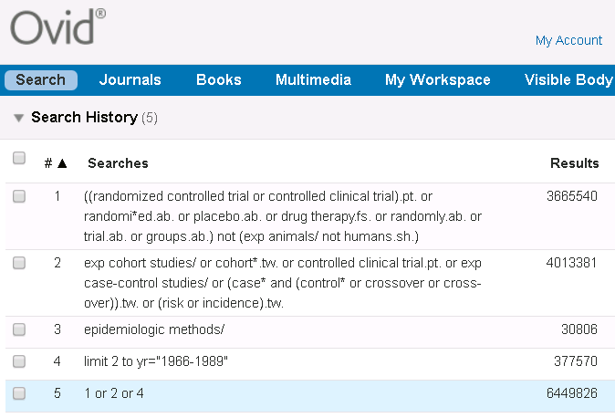  Source: modified from BMJ, http://bestpractice.bmj.com/info/toolkit/learn-ebm/study-design-search-filters/ | (cohort studies[mh] OR cohort*[tw] OR controlled clinical trial[pt] OR case-control studies[mh] OR (case*[tw] AND (control*[tw] OR crossover[tw] OR cross-over[tw] OR comparison*[tw])) "control group"[tw] OR "control groups"[tw] OR risk*[tw] OR incidence*[tw] OR (epidemiologic methods[mh:noexp] AND ("1966"[dp]:"1989"[dp])))  Source: modified from BMJ, http://bestpractice.bmj.com/info/toolkit/learn-ebm/study-design-search-filters/ | (MH "Prospective studies" OR MH "Case Control Studies+" OR MH "Correlational Studies" OR MH "Nonconcurrent Prospective Studies" OR (cohort W1 (study or studies)) OR (observational W1 (study OR studies)) OR (case* W4 (control* or crossover or cross-over)) OR (case N2 comparison*) OR "control group*" OR risk* OR incidence*)  Source: SIGN, http://www.sign.ac.uk/assets/search-filters-observational-studies.docx | ((cohort OR longitudinal OR prospective OR retrospective OR (MR "longitudinal study") OR (MR "prospective study") OR (MR "retrospective study") OR (case* W4 (control* OR crossover OR cross-over)) OR (case N2 comparison*) OR "control group*" OR risk* OR incidence*) NOT MR "Literature Review")  Source: modified from http://libguides.sph.uth.tmc.edu/ovid_psycinfo_filters  Methodology: MD [Ovid) = MR (EBSCO) | TS = ((cohort NEAR/1 (study or studies OR analys*)) OR (case* NEAR/4 (control* or crossover or cross-over)) OR (case NEAR/2 comparison*) OR "control group*" OR risk* OR incidence*)  Source: modified from SIGN, http://www.sign.ac.uk/assets/search-filters-observational-studies.docx
 |  |  |  |  | Scopus
title-abs-key ((cohort PRE/1 (study or studies OR analys*)) OR (case* PRE/4 (control* or crossover or cross-over)) OR (case W/2 comparison*) OR "control group*" OR risk* OR incidence*)

Source: modified from SIGN, http://www.sign.ac.uk/assets/search-filters-observational-studies.docx

附錄2-3-2: Observational Study: Cross-Sectional Study
(不同問題類型/研究設計、資料庫/平台，套用的Filters各異；紅字是有異於原始Filter；灰字可視研究題目刪除)
Embase [Elsevier] | Medline [Ovid] | Medline [PubMed] | CINAHL [EBSCOhost] | PsycInfo [EBSCOhost] | Web of Science
('cross-sectional study'/de OR 'correlational study'/de OR ('cross section*' OR crosssection* OR crossection* OR 'descriptive stud*'):ti,ab,kw)  Source: modified from Cochrane, https://www.cochrane.org/MR000041/METHOD_search-strategies-identify-observational-studies-medline-and-embase | (Cross-Sectional Studies/ OR ("cross section*" OR crosssection* OR crossection*).ti,ab.)  Source: modified from Cochrane, https://www.cochrane.org/MR000041/METHOD_search-strategies-identify-observational-studies-medline-and-embase | (Cross-Sectional Studies[mh:noexp] OR "cross section*"[tiab] OR crosssection*[tiab] OR crossection*[tiab])  Source: modified from Cochrane, http://bestpractice.bmj.com/info/toolkit/learn-ebm/study-design-search-filters/ | (MH ("Cross Sectional Studies" OR "Correlational Studies" OR "Descriptive Research") OR TI ("cross section*" OR crosssection* OR crossection* OR correlational OR "descriptive stud*" OR AB ("cross section*" OR crosssection* OR crossection* OR correlational OR "descriptive stud*"))  Source: modified from Cochrane, http://bestpractice.bmj.com/info/toolkit/learn-ebm/study-design-search-filters/ |  | TS=("cross section*" OR crosssection* OR crossection*)  Source: modified from Cochrane, http://bestpractice.bmj.com/info/toolkit/learn-ebm/study-design-search-filters/
 |  |  |  |  | Scopus
title-abs-key ("cross section*" OR crosssection* OR crossection*)

Source: modified from Cochrane, http://bestpractice.bmj.com/info/toolkit/learn-ebm/study-design-search-filters/

附錄2-4: Qualitative Study (不同研究問題類型/研究設計、資料庫/平台，套用的Filters各異)
此區為成大醫圖自行彙整，可再加入研究所屬領域中較常使用的質性研究方法。亦可參考: https://hiruweb.mcmaster.ca/hkr/hedges/
Embase.com [Elsevier] | Medline [Ovid] | Medline [PubMed] | CINAHL [EBSCOhost] | PsycInfo [Ovid] | Web of Science
('qualitative research'/exp OR 'interview'/exp OR (qualitative OR interview* OR themes OR experience*):ti,ab,kw | (exp "Qualitative Research"/ OR interview.pt OR (qualitative OR interview* OR themes OR experience*).ti,ab,kf) | ("Qualitative Research"[mh] OR interview[pt] OR qualitative[tiab] OR interview*[tiab] OR themes[tiab] OR experience*[tiab]) | (MH ("Qualitative Studies+" OR "Interview+") OR TI (qualitative OR interview* OR themes OR experience*) OR AB (qualitative OR interview* OR themes OR experience*)) | (exp "Qualitative Methods"/ OR exp "Interview"/ OR (qualitative OR interview* OR themes OR experience*).ti,ab,kf)  包含mixed methods:  (exp "Qualitative Methods"/ OR exp "Interview"/ exp "Experiences (Events)"/ OR exp "Mixed Methods Research"/ OR (qualitative OR interview* OR themes OR experience* OR "mixed method*").ti,ab,kf) | TS = (qualitative OR interview* OR themes OR experience*)
 |  |  |  | Psychology and Behavioral Sciences Collection: PBSC (EBSCOhost) | Scopus
 |  |  |  | -- | Title-Abs-Key (qualitative OR interview* OR themes OR experience*)

附錄2-5: Systematic Review (不同研究問題類型/研究設計、資料庫/平台，套用的Filters各異)
Embase.com [Elsevier] | Medline [Ovid] | Medline [PubMed] | CINAHL [EBSCOhost] | Web of Science | 華藝
((("review"/exp OR (literature NEAR/3 review*):ti,ab) AND ((medline or medlars or embase or pubmed or cinahl or amed or psychlit or psyclit or psychinfo or psycinfo or scisearch or cochrane):ti,ab OR "RETRACTED ARTICLE"/de)) OR ((systematic* NEAR/2 (review* or overview)) OR meta$anal* or "meta anal*" or "meta-anal*" or metaanal* or metanal*):ti,ab OR "meta analysis"/exp OR "systematic review"/exp)  Source: modify SR filter from BMJ Best Practice  https://bestpractice.bmj.com/info/toolkit/learn-ebm/study-design-search-filters/ | ((review.pt. AND ((medline or medlars or embase or pubmed or cochrane or scisearch or psychinfo or psycinfo or psychlit or psyclit or cinahl or (hand adj2 search$) or (manual$ adj2 search$) or "electronic database$" or "bibliographic database$" or "computeri?ed database$" or "online database$" or pooling or pooled or "mantel haenszel" or peto or dersimonian or "der simonian" or "fixed effect").tw,sh. or "retraction of publication".pt or "retracted publication".pt)) OR "meta-analysis".pt. or "meta-analysis".sh. OR (meta-analys$ or "meta analys$" or metaanalys$ or (systematic$ adj5 review$) or (systematic$ adj5 overview$) or (quantitativ$ adj5 review$) or (quantitativ$ adj5 overview$) or (quantitativ$ adj5 synthesis$) or (methodologic$ adj5 review$) or (methodologic$ adj5 overview$)).tw,sh OR "integrative research review$".tw or "research integration".tw)  Source: modify SR filter from BMJ Best Practice  https://bestpractice.bmj.com/info/toolkit/learn-ebm/study-design-search-filters/ | ((review[pt] AND (medline OR medlars OR embase OR pubmed OR cochrane OR scisearch OR psychinfo OR psycinfo OR psychlit OR psyclit OR cinahl OR (hand AND search*) OR (manual* AND search*) OR "electronic database*" OR "bibliographic database*" OR "computerised database*" OR "computerized database*" OR "online database*" OR pooling OR pooled OR "mantel haenszel" OR peto OR dersimonian OR "der simonian" OR "fixed effect" OR "retraction of publication"[pt] OR "retracted publication"[pt])) OR "meta-analysis"[pt] OR meta-analys* OR "meta analys*" OR metaanalys* OR ((systematic* OR quantitative* OR methodologic*) AND (review* OR overview*)) OR "integrative research review*" OR "research integration")  Source: modify SR filter from BMJ Best Practice  https://bestpractice.bmj.com/info/toolkit/learn-ebm/study-design-search-filters/ | ((TI (systematic* N3 review*)) OR (AB (systematic* N3 review*)) OR (TI (systematic* N3 bibliographic*)) OR (AB (systematic* N3 bibliographic*)) OR (TI (systematic* N3 literature)) OR (AB (systematic* N3 literature)) OR (TI (comprehensive* N3 literature)) OR (AB (comprehensive* N3 literature)) OR (TI (comprehensive* N3 bibliographic*)) OR (AB (comprehensive* N3 bibliographic*)) OR (TI (integrative N3 review)) OR (AB (integrative N3 review)) OR (JN “Cochrane Database of Systematic Reviews") OR (TI (information N2 synthesis)) OR (TI (data N2 synthesis)) OR (AB (information N2 synthesis)) OR (AB (data N2 synthesis)) OR (TI (data N2 extract*)) OR (AB (data N2 extract*)) OR (TI (medline OR pubmed OR psyclit OR cinahl OR (psycinfo NOT "psycinfo database") OR "web of science" OR scopus OR embase)) OR (AB (medline OR pubmed OR psyclit OR cinahl OR (psycinfo not "psycinfo database") OR "web of science" OR scopus OR embase)) OR (MH "Systematic Review") OR (MH "Meta Analysis") OR (TI (meta-analy* OR metaanaly*)) OR (AB (meta-analy* OR metaanaly*)))  Source: SR filter from https://libguides.sph.uth.tmc.edu/search_filters/cinahl_filters | ((DT=(Review) and (TS=(medline or medlars or embase or pubmed or cochrane or scisearch or psychinfo or psycinfo or psychlit or psyclit or cinahl or (hand NEAR/3 search*) or (manual* NEAR/3 search*) or "electronic database*" or "bibliographic database*" or "computeri*ed database*" or "online database*" or pooling or pooled or "mantel haenszel" or peto or dersimonian or "der simonian" or "fixed effect") or DT=("Retracted Publication"))) OR TS=(meta-analys* or "meta analys*" or metaanalys* or (systematic* NEAR/4 review*) or (systematic* NEAR/4 overview*) or (quantitativ* NEAR/4 review*) or (quantitativ* NEAR/4 overview*) or (quantitativ* NEAR/4 synthesis*) or (methodologic* NEAR/4 review*) or (methodologic* NEAR/4 overview*)) OR TS=("integrative research review*" or "research integration"))  Source: modify SR filter from BMJ Best Practice  https://bestpractice.bmj.com/info/toolkit/learn-ebm/study-design-search-filters/ | [ALL3]:(系統性 OR 系統回顧 OR 系統綜述 OR 系統評價 OR 統合分析 OR 薈萃分析 OR 整合分析 OR 元分析 OR meta* OR "systematic* review*" OR "systematic* overview*" OR "quantitativ* review*" OR "quantitativ* overview*" OR "quantitativ* synthes*" OR "methodologic* review*" OR "methodologic* overview*" OR "integrative research review*" OR "research* integration*" OR "systematic* literature*" OR "comprehensive review*" OR "integrative review" OR "evidence synthes*" OR "pool* analys*" OR "survey paper*")  註: "系統性"結合題目仍找到過多不相關文章時，需要調整檢索詞。  Source: NCKU Medical Library
 |  |  |  | Scopus | CNKI
 |  |  |  | ((DOCTYPE(RE) AND (Title-Abs-Key (medline or medlars or embase or pubmed or cochrane or scisearch or psychinfo or psycinfo or psychlit or psyclit or cinahl or (hand w/3 search*) or (manual* w/3 search*) or "electronic database*" or "bibliographic database*" or "computeri*ed database*" or "online database*" or pooling or pooled or "mantel haenszel" or peto or dersimonian or "der simonian" or "fixed effect") or DOCTYPE(tb))) OR Title-Abs-Key (meta-analys* or "meta analys*" or metaanalys* or (systematic* w/4 review*) or (systematic* w/4 overview*) or (quantitativ* w/4 review*) or (quantitativ* w/4 overview*) or (quantitativ* w/4 synthesis*) or (methodologic* w/4 review*) or (methodologic* w/4 overview*)) OR Title-Abs-Key ("integrative research review*" or "research integration"))  Source: modify SR filter from BMJ Best Practice  https://bestpractice.bmj.com/info/toolkit/learn-ebm/study-design-search-filters/ | SU=(系统性 + 系统回顾 + 系统综述 + 系统评价 + 统合分析 + 荟萃分析 + 整合分析 + 元分析 + meta + metaanalysis + metaanalyses + "systematic review" + "systematic overview" + "quantitative review" + "quantitative overview" + "quantitative synthesis" + "methodologic review" + "methodologic overview" + "integrative research review" + "research integration" + "systematic literature" + "comprehensive review" + "integrative review" + "evidence synthesis" + "pooled analysis" + "pooling analysis" + "survey paper")  註: "系統性"結合題目仍找到過多不相關文章時，需要調整檢索詞。  Source: NCKU Medical Library
 |  |  |  | PsycInfo [Ovid] | 萬方數據
 |  |  |  | (((literature review.md. or exp "literature review"/) AND ((medline or medlars or embase or pubmed or cochrane or scisearch or psychinfo or psycinfo or psychlit or psyclit or cinahl or (hand adj2 search*) or (manual* adj2 search*) or "electronic database*" or "bibliographic database*" or "computeri?ed database*" or "online database*" or pooling or pooled or "mantel haenszel" or peto or dersimonian or "der simonian" or "fixed effect").tw,sh. or retraction.dt.)) OR systematic review.md OR "meta-analysis".md. or metasynthesis.md. OR (meta-analys* or "meta analys*" or metaanalys* or (systematic* adj5 review*) or (systematic* adj5 overview*) or (quantitativ* adj5 review*) or (quantitativ* adj5 overview*) or (quantitativ* adj5 synthesis*) or (methodologic* adj5 review*) or (methodologic* adj5 overview*)).tw,sh OR "integrative research review*".tw or "research integration".tw)  Source: modify SR filter from BMJ Best Practice  https://bestpractice.bmj.com/info/toolkit/learn-ebm/study-design-search-filters/ | 主題:("系統性" OR "系統回顧" OR "系統綜述" OR "系統評價" OR "統合分析" OR "薈萃分析" OR "整合分析" OR "元分析" OR meta* OR "systematic* review*" OR "systematic* overview*" OR "quantitativ* review*" OR "quantitativ* overview*" OR "quantitativ* synthes*" OR "methodologic* review*" OR "methodologic* overview*" OR "integrative research review*" OR "research* integration*" OR "systematic* literature*" OR "comprehensive review*" OR "integrative review" OR "evidence synthes*" OR "pool* analys*" OR "survey paper*")  註: "系統性"結合題目仍找到過多不相關文章時，需要調整檢索詞。  Source: NCKU Medical Library

附錄2-6: Guideline (不同研究問題類型/研究設計、資料庫/平台，套用的Filters各異)
Embase.com [Elsevier] | Medline [Ovid] | Medline [PubMed] | CINAHL [EBSCOhost] | Web of Science | Scopus
[完整度高]  ("practice guideline"/exp OR (guideline* OR (consensus NEAR/3 (conference* OR congress* OR meeting* OR workshop* OR work-shop* OR proceeding* OR symposium* OR seminar* OR development*))):ti,ab,kw) | [完整度高]  (exp "Guideline"/ OR exp "Practice Guidelines as Topic"/ OR exp "Consensus Development Conference"/ OR (guideline* OR (consensus ADJ3 (conference* OR congress* OR meeting* OR workshop* OR work-shop* OR proceeding* OR symposium* OR seminar* OR development*))).ti,ab,kf) | --- | [完整度高]  (MH "Practice Guidelines+" OR PT "Practice Guidelines" OR MH "Consensus+" OR (guideline* OR (consensus N2 (conference* OR congress* OR meeting* OR workshop* OR work-shop* OR proceeding* OR symposium* OR seminar* OR development*)))) | [完整度高]  TS = (guideline* OR (consensus NEAR/2 (conference* OR congress* OR meeting* OR workshop* OR work-shop* OR proceeding* OR symposium* OR seminar* OR development*))) | [完整度高]  title-abs-key = (guideline* OR (consensus W/2 (conference* OR congress* OR meeting* OR workshop* OR work-shop* OR proceeding* OR symposium* OR seminar* OR development*)))
[精準度高]  ("practice guideline"/exp OR (guideline* OR (consensus NEAR/3 (conference* OR congress* OR meeting* OR workshop* OR work-shop* OR proceeding* OR symposium* OR seminar* OR development*))):ti) | [精準度高]  (exp "Guideline"/ OR exp "Practice Guidelines as Topic"/ OR exp "Consensus Development Conference"/ OR (guideline* OR (consensus ADJ3 (conference* OR congress* OR meeting* OR workshop* OR work-shop* OR proceeding* OR symposium* OR seminar* OR development*))).ti) | --- | [精準度高]  (MH "Practice Guidelines+" OR PT "Practice Guidelines" OR MH "Consensus+" OR TI (guideline* OR (consensus N2 (conference* OR congress* OR meeting* OR workshop* OR work-shop* OR proceeding* OR symposium* OR seminar* OR development*)))) | [精準度高]  TI = (guideline* OR (consensus NEAR/2 (conference* OR congress* OR meeting* OR workshop* OR work-shop* OR proceeding* OR symposium* OR seminar* OR development*))) | [精準度高]  title = (guideline* OR (consensus W/2 (conference* OR congress* OR meeting* OR workshop* OR work-shop* OR proceeding* OR symposium* OR seminar* OR development*)))

